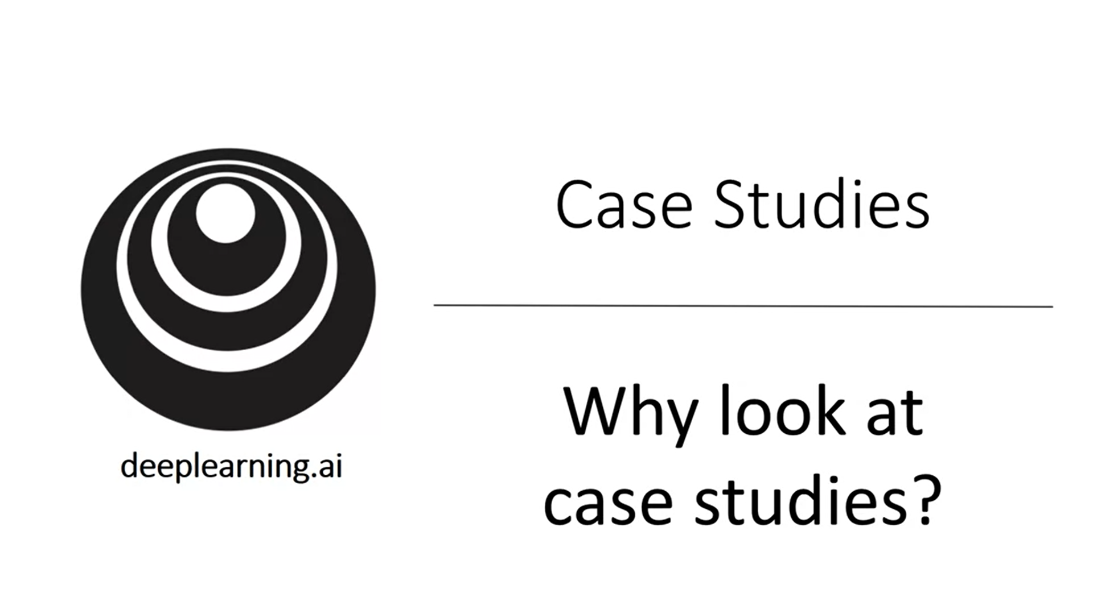

A lot of computer vision research was about putting together the basic building blocks to build effective conv nets.

A good way to get intuition about how to build conv nets that work well is to look at how others have built conv nets.

A neural network architecture that works well on one computer vision task often works well on other tasks.

It is important to be able to read research papers so we will learn about terminology and history etc.

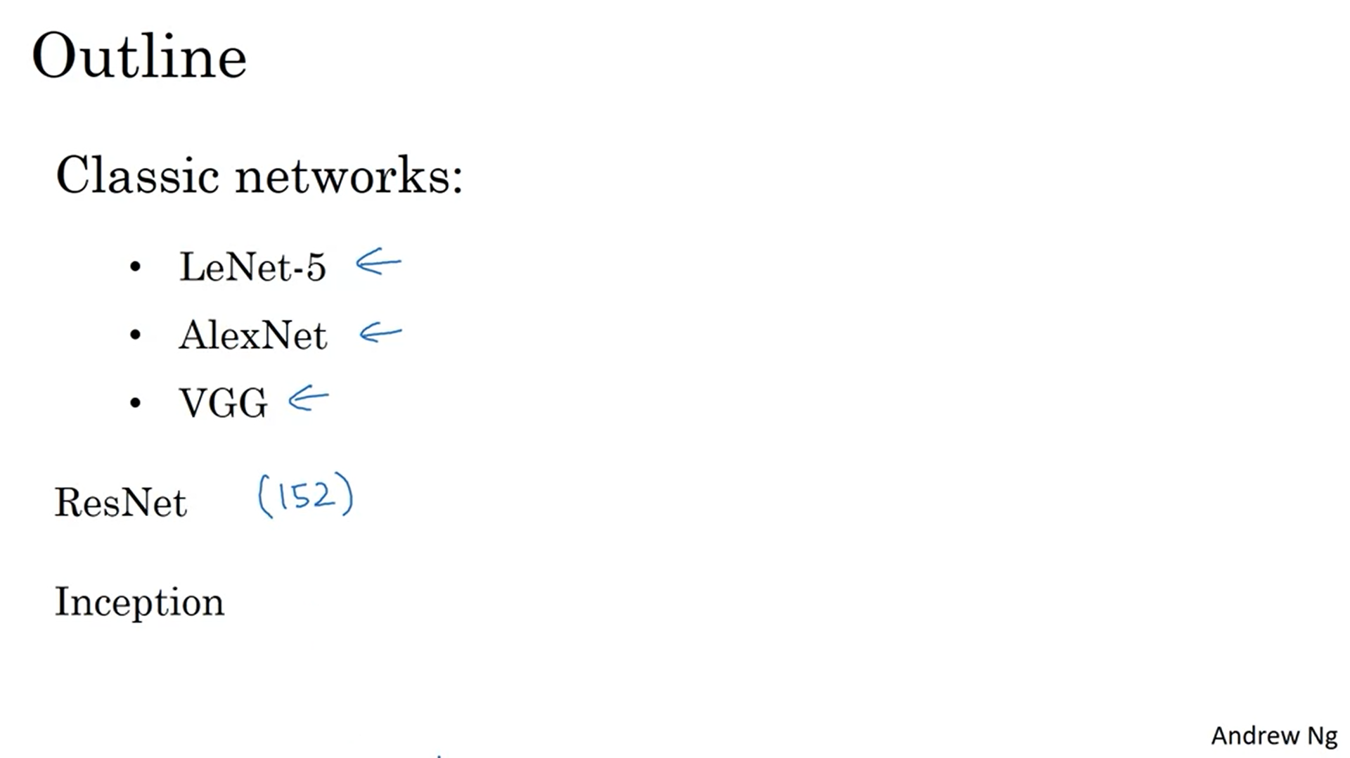

LeNet-5: 1980s

Some of the ideas laid the foundation for modern computer vision.

ResNet has some tricks how to train very deep neural nets -> 152 layers.

Even if you end up not working in computer vision, many of these ideas crossfertilize other areas.

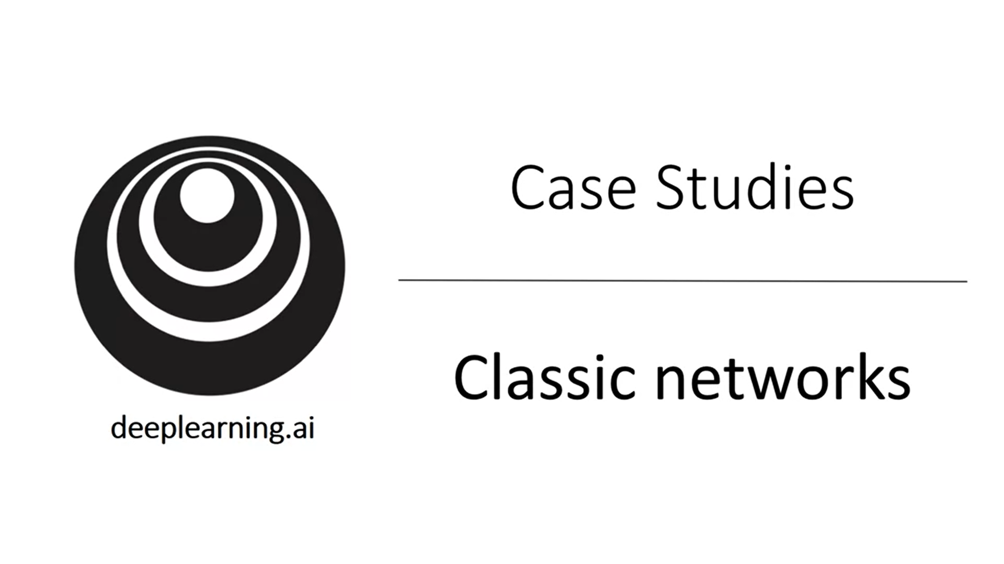 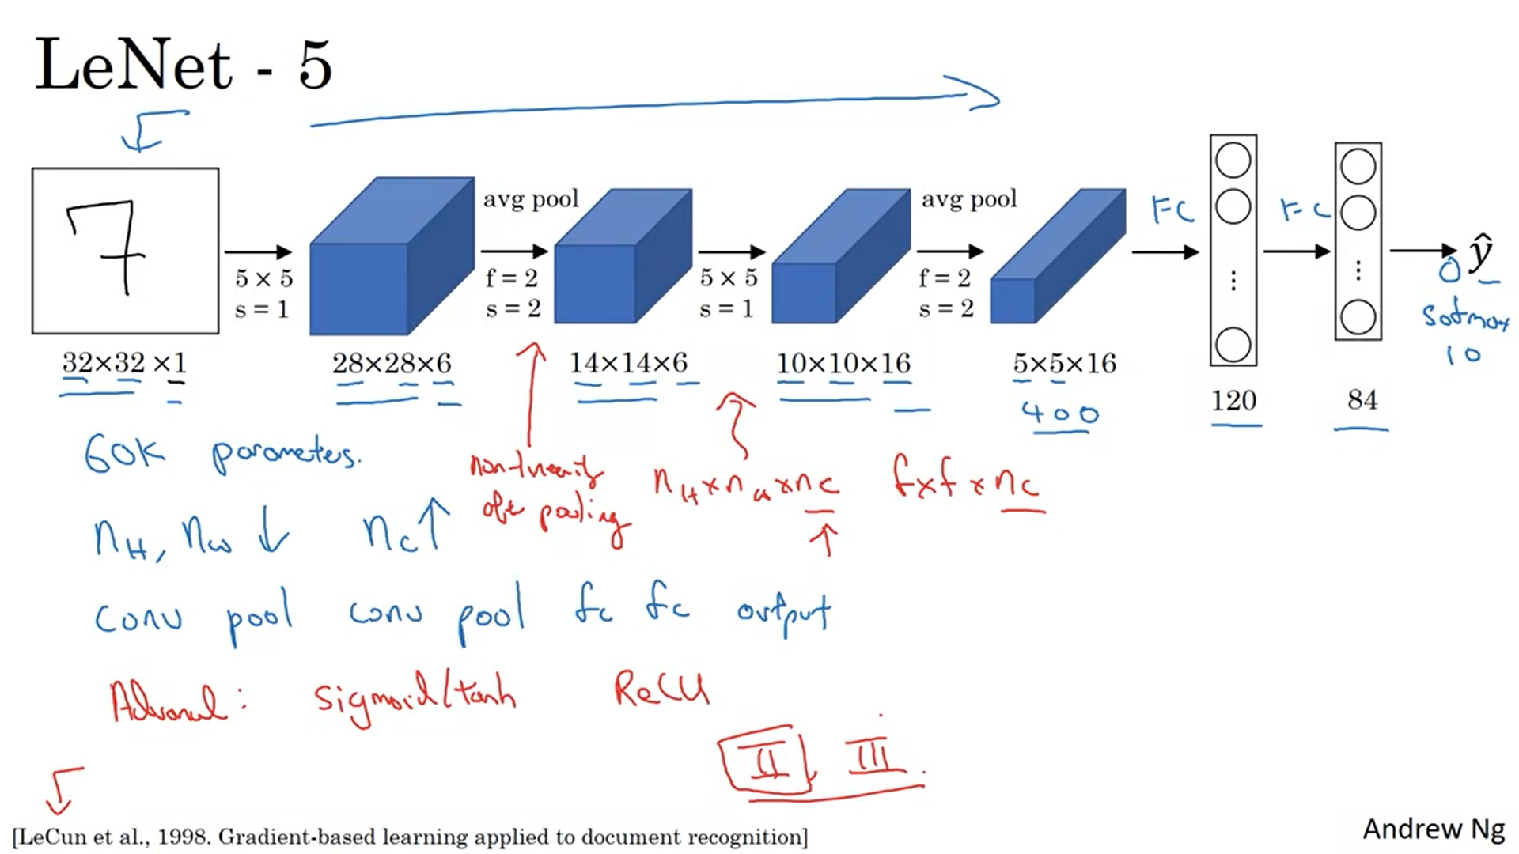

The goal was to recognize handwritten digits.

Back then when the paper was written avg pooling was used more often. Now this would be replaced by max pooling.

People did not use padding when this paper was written (the size shrinked quite fast).

A modern version of this network will use a softmax layer. Back then a different classifier at the output layer was used.

This neural net is small by modern standards: 60k parameters. Today more like 10M to 100M parameters.

The arrangement of layers is quite common.

Red is historical footnote. People back then were using sigmoid and tanh not ReLU. Computers were much slower back then so there was some advanced logic that different filters only looked at some channels (not like today every filter for every channel). Another thing that was done back then is that there was a non-linearity after the pooling layer. Most of the ideas described here are in section II and III of the paper. The paper also talks about some other ideas that are not used anymore today.

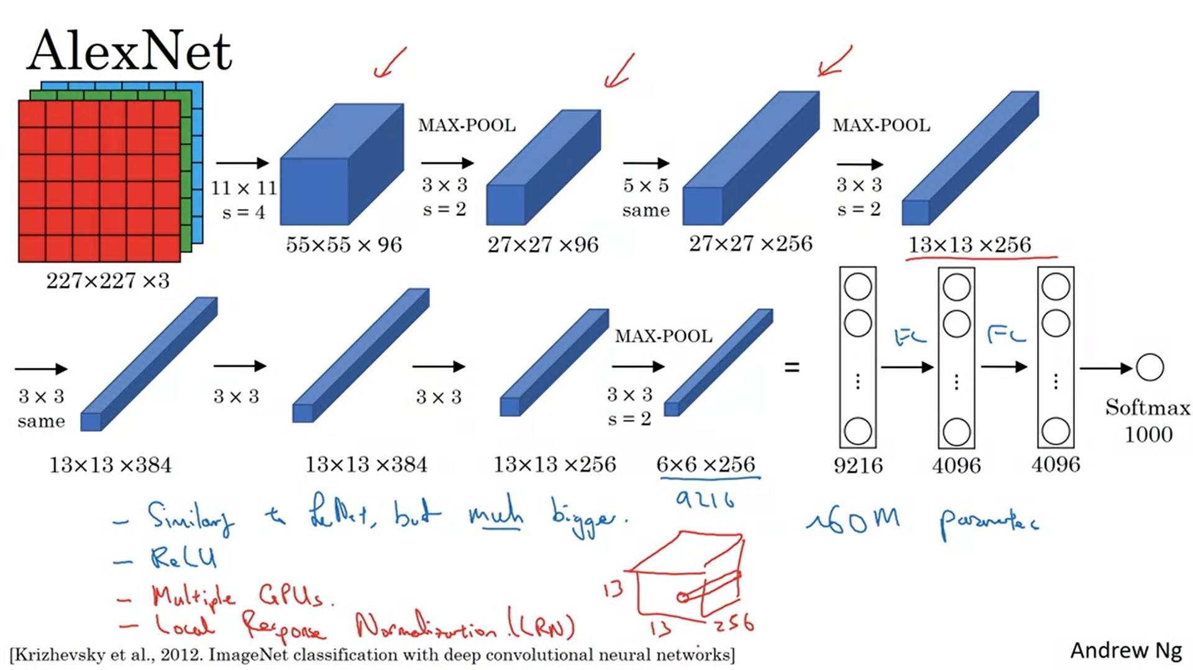

The paper talks about 224x224x3 images but the numbers only make sense with 227x227x3 images.

AlexNet was trained on the ImageNet dataset. A lot more hidden units than LeNet-5.

Using the ReLU activation function also made it much better than LeNet-5.

GPUs back then were not so powerful so there was a complicated way to train on multiple GPUs in parallel (the training of the layers was thoughtfully split).

Also there was another layer called Local Response Normalization: It looks at one position across all the channels and normalizes them. The intuition was that we do not want too many neurons with too high an activation in these positions. Researchers have subsequently found that this is not so helpful.

Previously AlexNet was gaining traction in speech recognition but it was really this paper that convinced a lot of the computer vision community.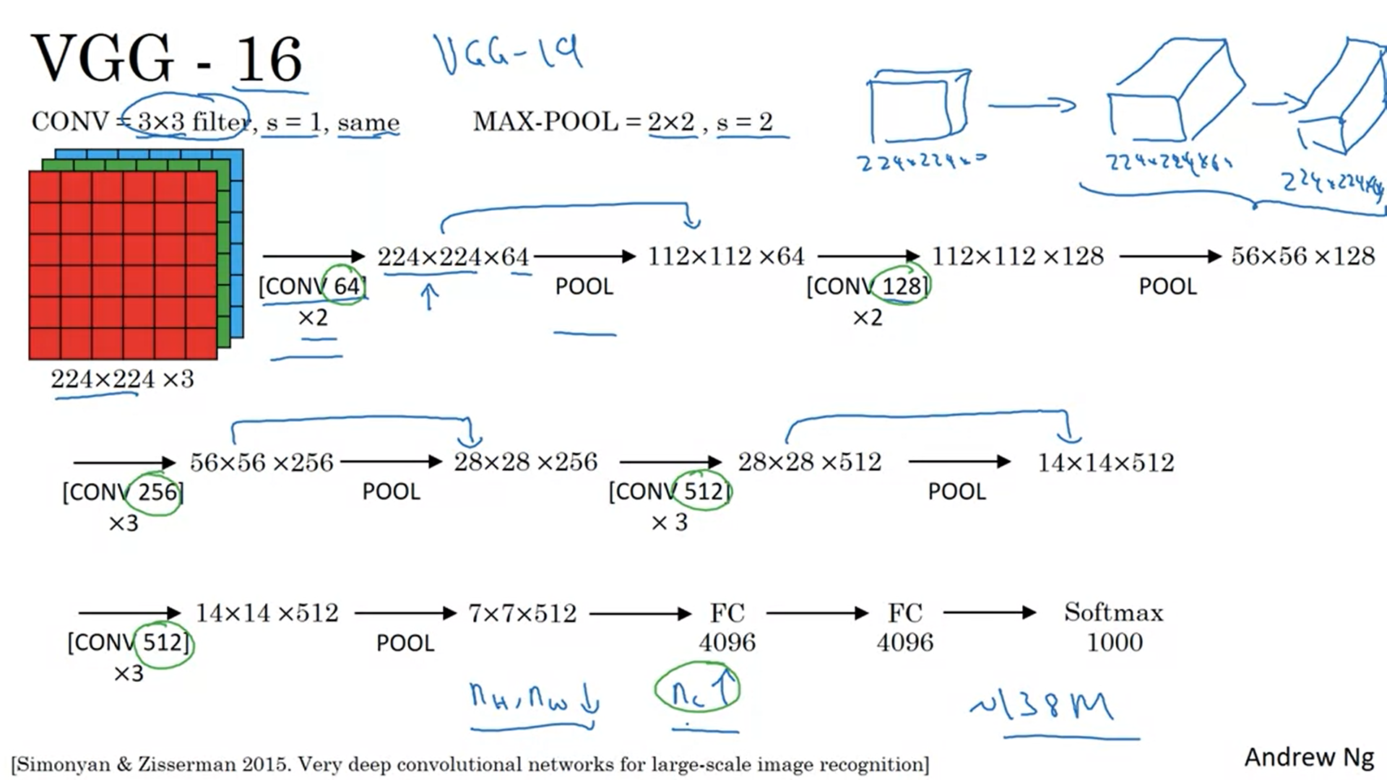

A much simpler network. The layers are standardized and simplified. VGG-16 is a relatively deep network. It uses same convolutions.

The 16 refers to 16 layers with weights. This is a pretty large network even given modern standards. But it is a very uniform architecture.

VGG-19 is an even bigger version of this network. However, VGG-16 performs almost as well so that many people use VGG-16.

The rate at which n_H and n_W go down and n_C goes up is very systematic in this paper.

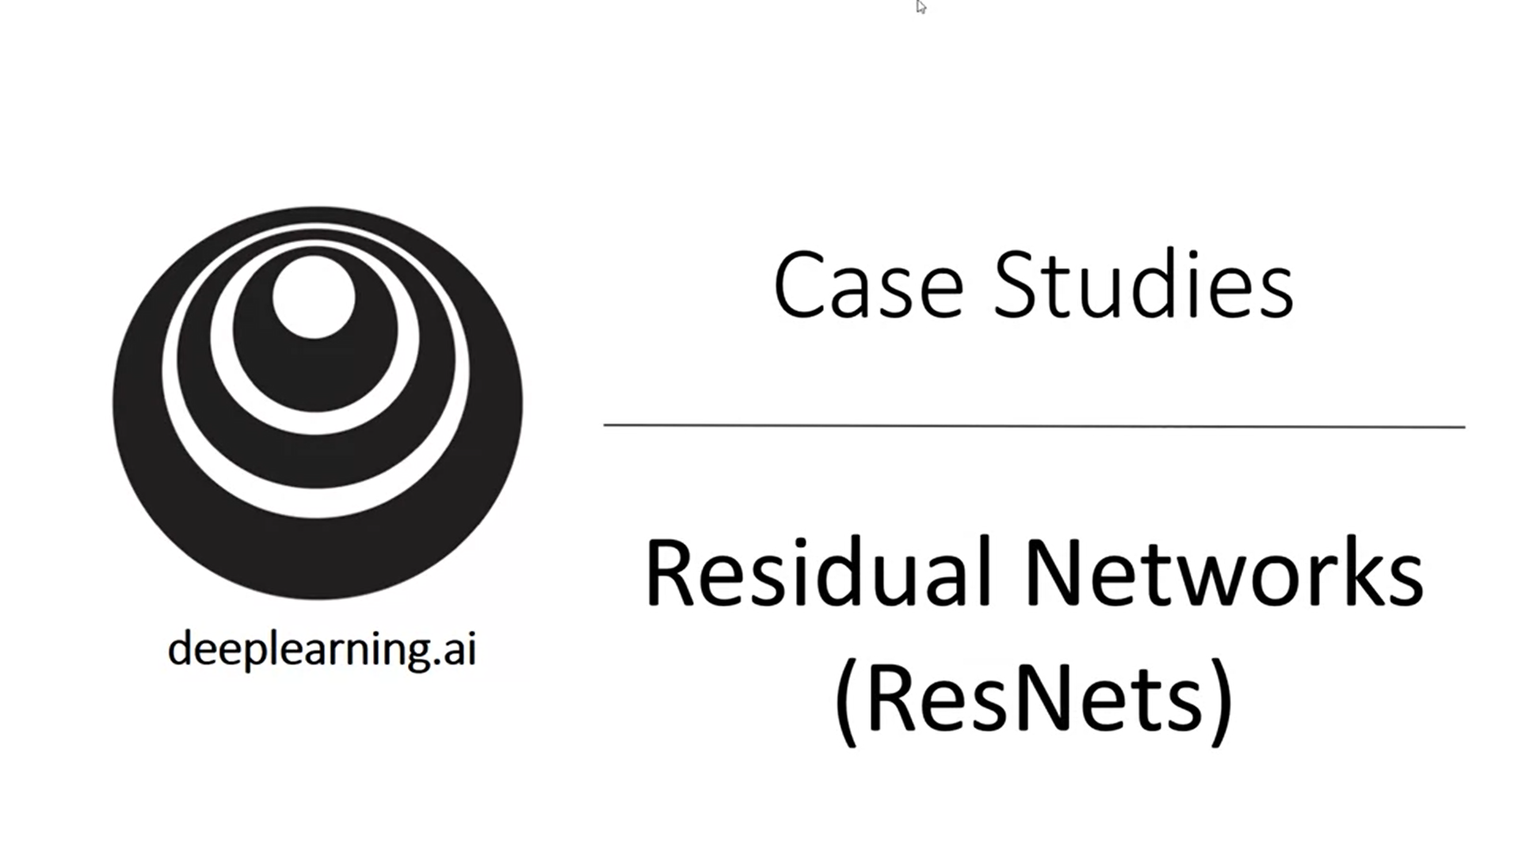

Let’s look at more advanced, more powerful network architectures.

Very deep neural networks are challenging to train because of vanishing / exploding gradients problems. ResNets use skip connections: they take the activation from one layer and suddenly feed it to another layer much deeper into the network. This allows to train very deep networks, even networks with >100 layers.

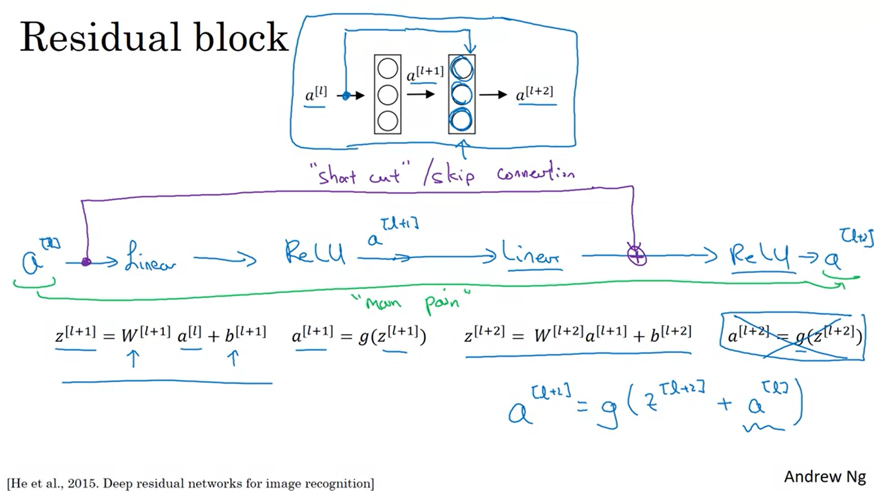

Let’s first describe a residual block.

The information from a_L can now follow a shortcut and skip a vast part until before the activation of a deeper layer.

Using residual blocks allows to train much deeper networks.

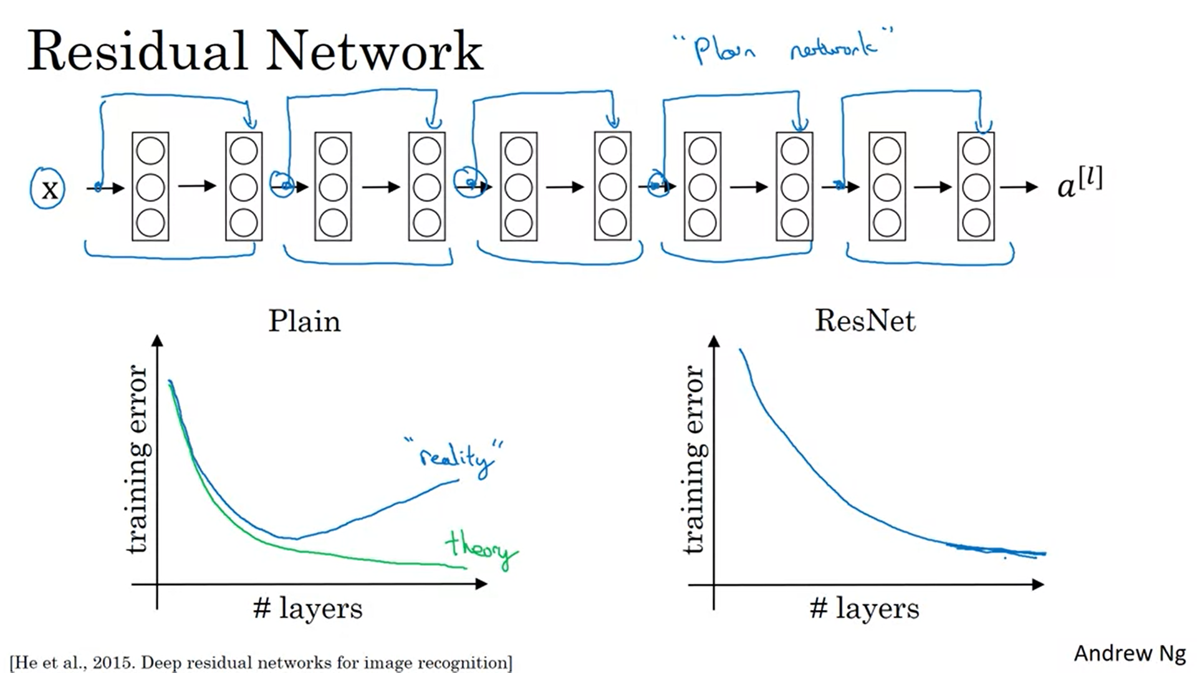

Add skip connections to plain network to make it a residual net.

Empirically with a plain network, the error goes up when you go to deep (goes against theory). The optimization algorithm has a hard time to train the network. This is not the case with a residual net.

Some people start to experiment with networks that have >1000 layers.

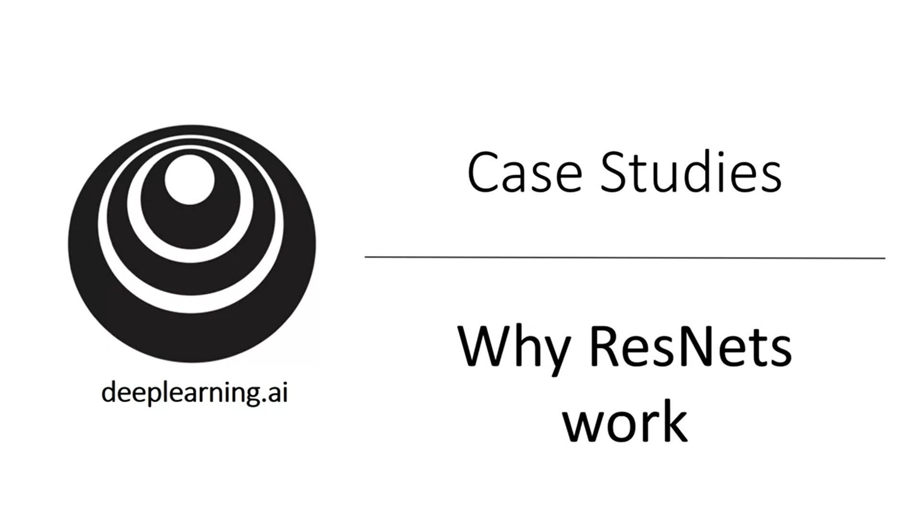

Remember: doing well on the training set is usually a prerequisite to do well on the dev and test set. So it is important to do well on the training set.

We have seen that making a network deeper can hurt the ability to do well on the training set.

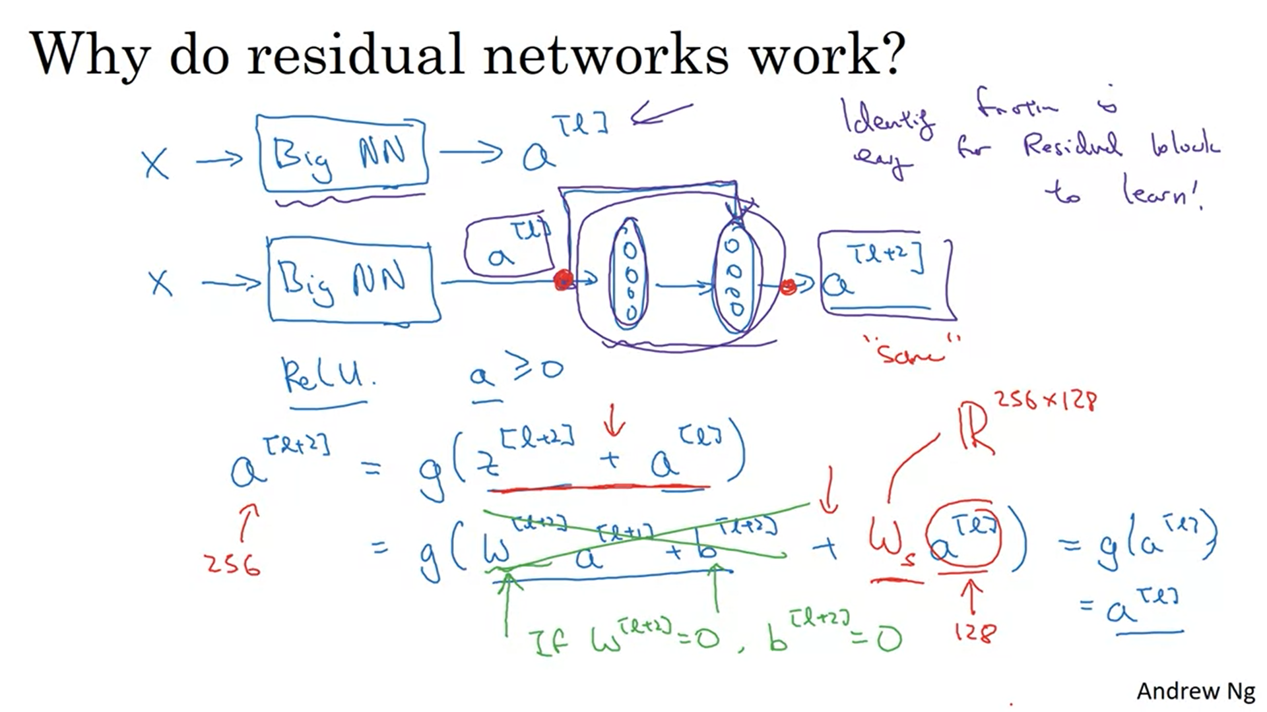

Let’s say we have a big NN and add some more layers as a residual block (with ReLU).

If we are using L2 regularization that will tend to shrink the value of W_l+2. Let’s say for the sake of argument we also regularize b. So these terms will go away.

The identity function is easy to learn for a residual block! That means that adding the two layers does not really hurt the network’s ability to do as well as the leaner network. Adding the residual block can only help. In the ideal scenario they help and learn something different than the identity function.

In a plain neural network it is really difficult to learn parameters that reflect the identity function.

We are assuming that z_l+2 and a_l have the same dimension -> we are seeing a lot of same convolutions in resnets. If they are not the same dimension we have to add an additional weight matrix (in red). It could be matrix that has to be learned or it could just implement 0 padding for example.

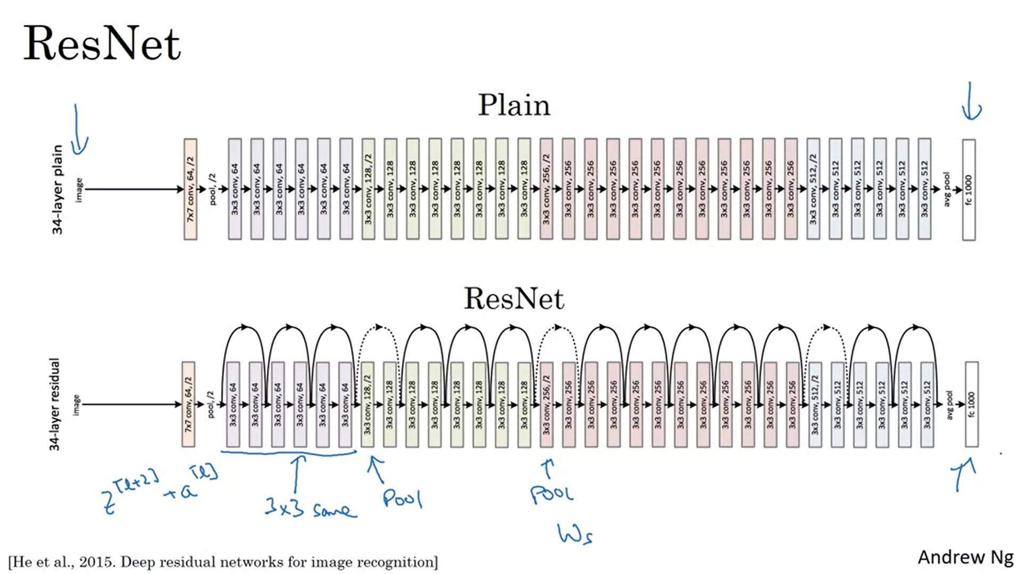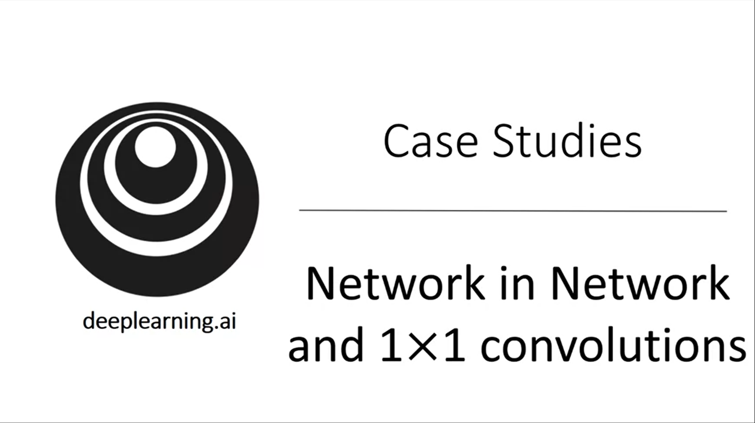

In terms of designing convnets it can really help to add 1x1 convolutions.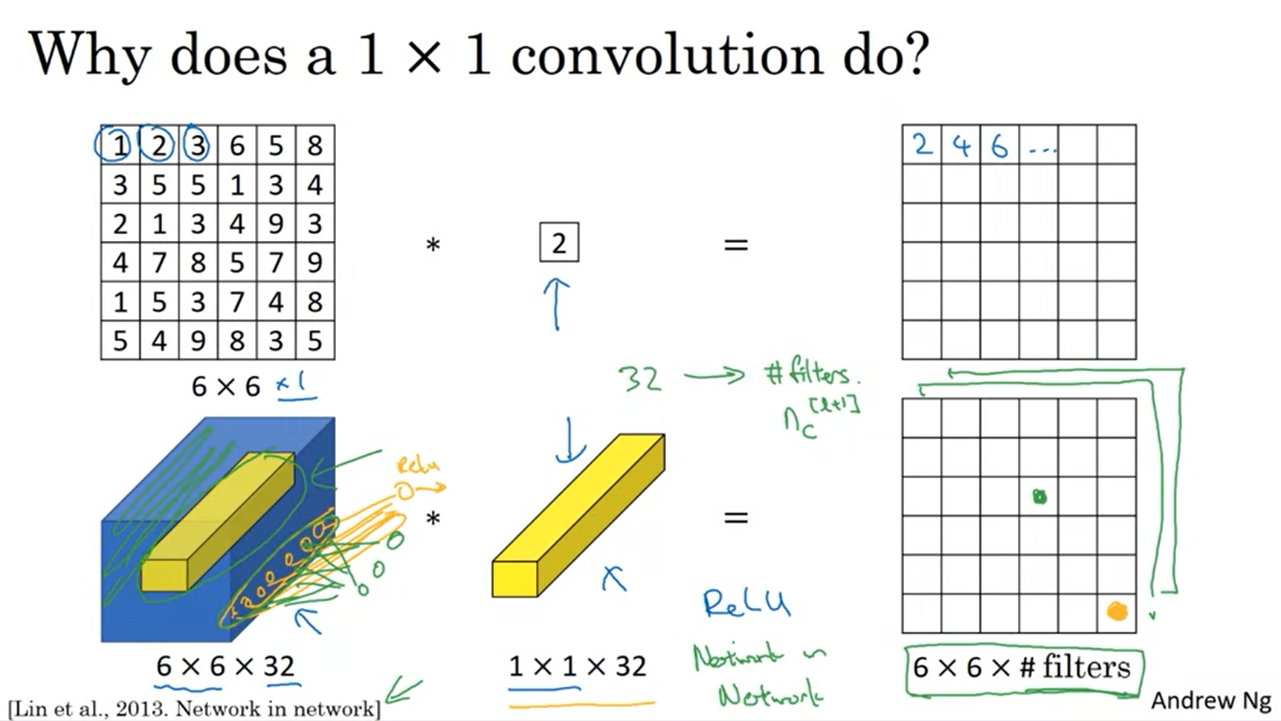

For 1-channel images this is not particularly useful but it is for volumes with multiple channels.

32 numbers in the 1x1x32 filter. Think of this as one neuron with 32 weights. If you have multiple filters you have multiple units. So one way to think about this is a fully connected neural network that applies to each of the channel positions. This can carry out a pretty non-trivial computation.

This idea is also called network in network and has been very influential for successful network architectures. 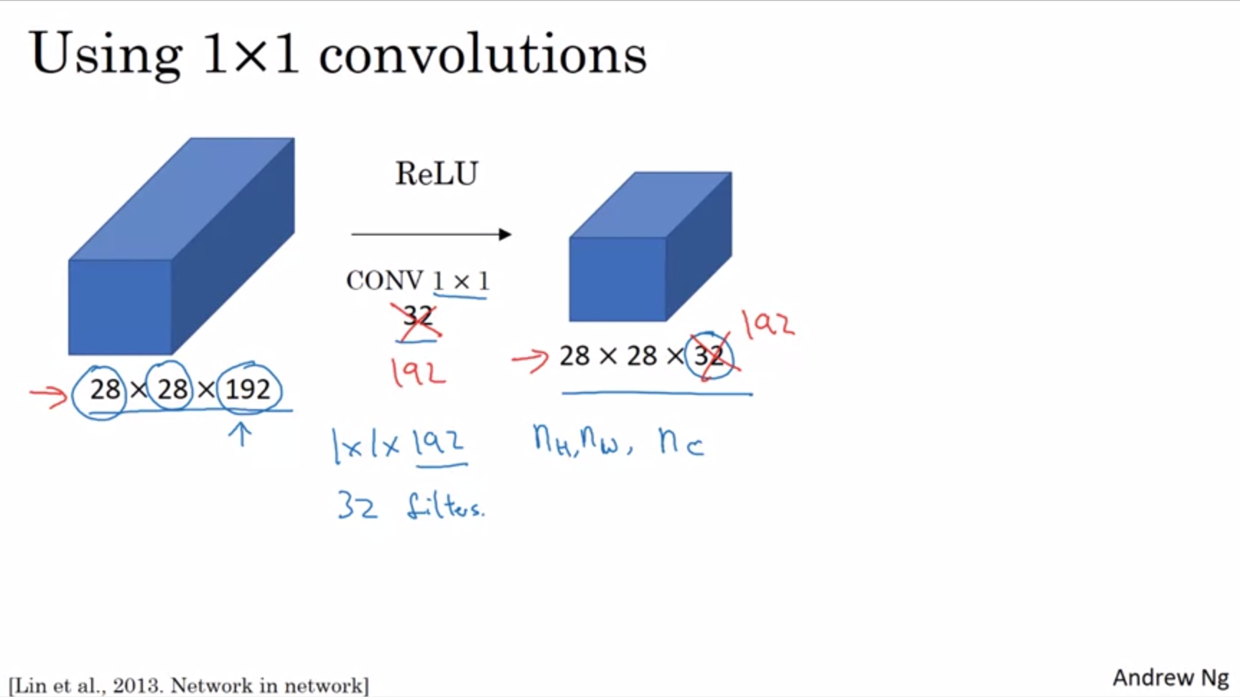

With pooling layers you can shrink the height and the width. With a 1x1 convolution you can shrink the channels.

You can also keep the number of channels the same and add non-linearity by using 192 filters (or even increase the number of channels).



With a normal convnet you have to pick between a 1x1, 3x3, 5x5 filter etc. The inception network uses them all! It makes the network architecture more complicated but works remarkably well.

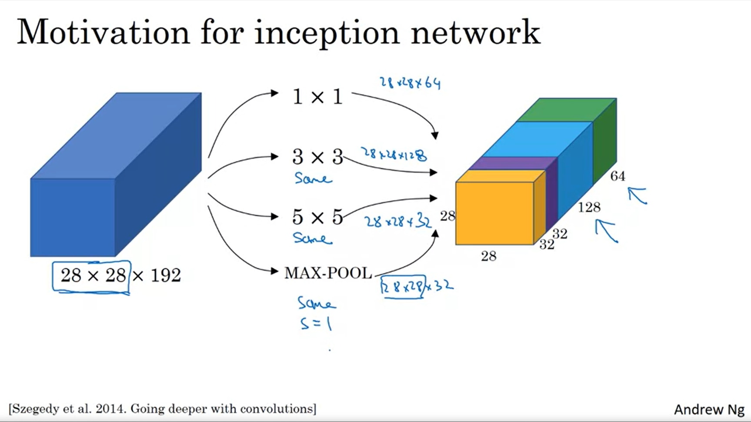

Stack up the different volumes. Also apply pooling with padding. Padding is needed to make the dimensions match. This is an unusual form of pooling.

Instead of committing to one filter pick them all and let the network learn the best weights.

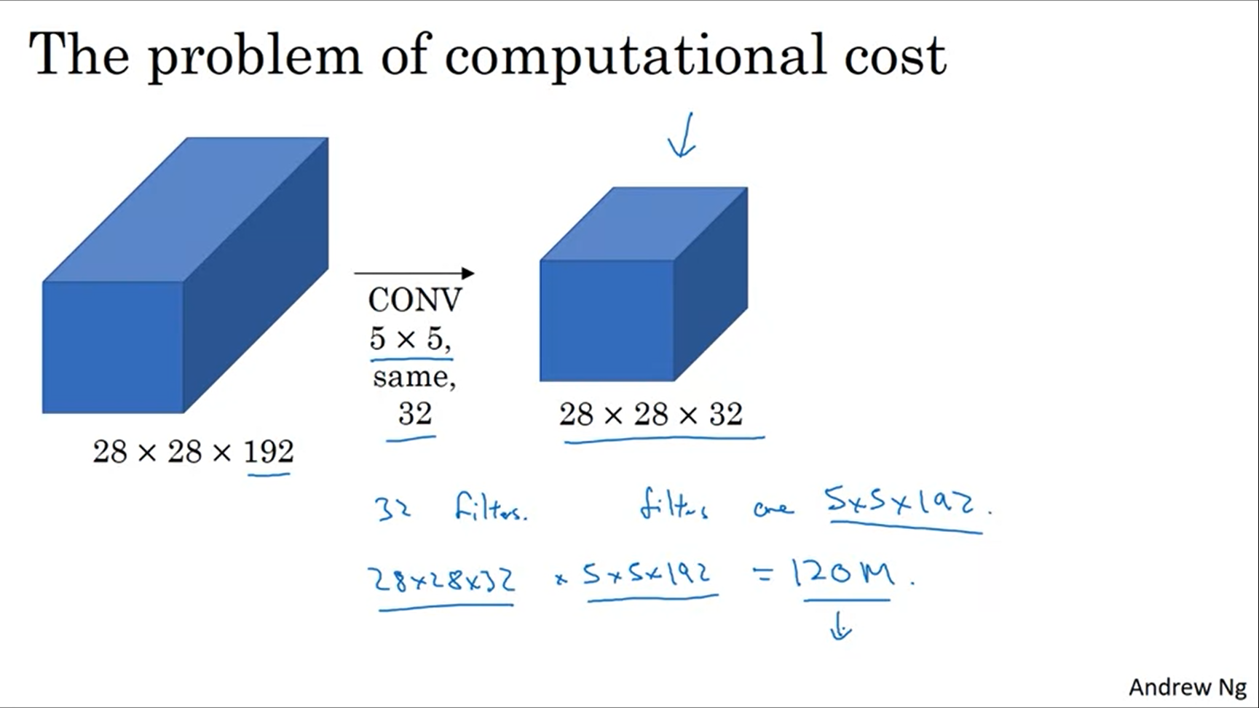

This is the purple block from the previous slide.

Total number of computations (multiplications): 120M

Using 1x1 convolutions it is possible to reduce the computations by a factor of 10.

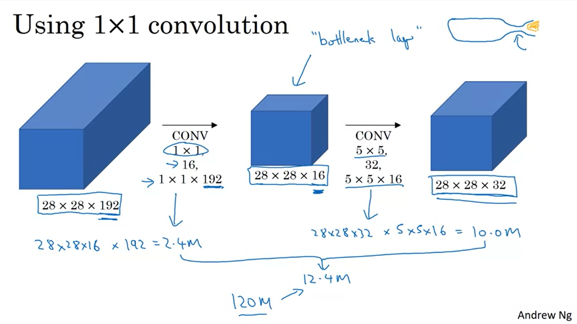

Idea: first reduce the number of channels (bottleneck layer), then run your 5x5 convolution on a much smaller volume.

The number of additions you need to do is very similar to the number of multiplications.

Like this, we can reduce the computational cost significantly. This does not seem to hurt performance as long as you implement the bottleneck layer “within reason”.

These are the key ideas of the inception network.



Put together the building blocks from the previous video to build the full inception network.

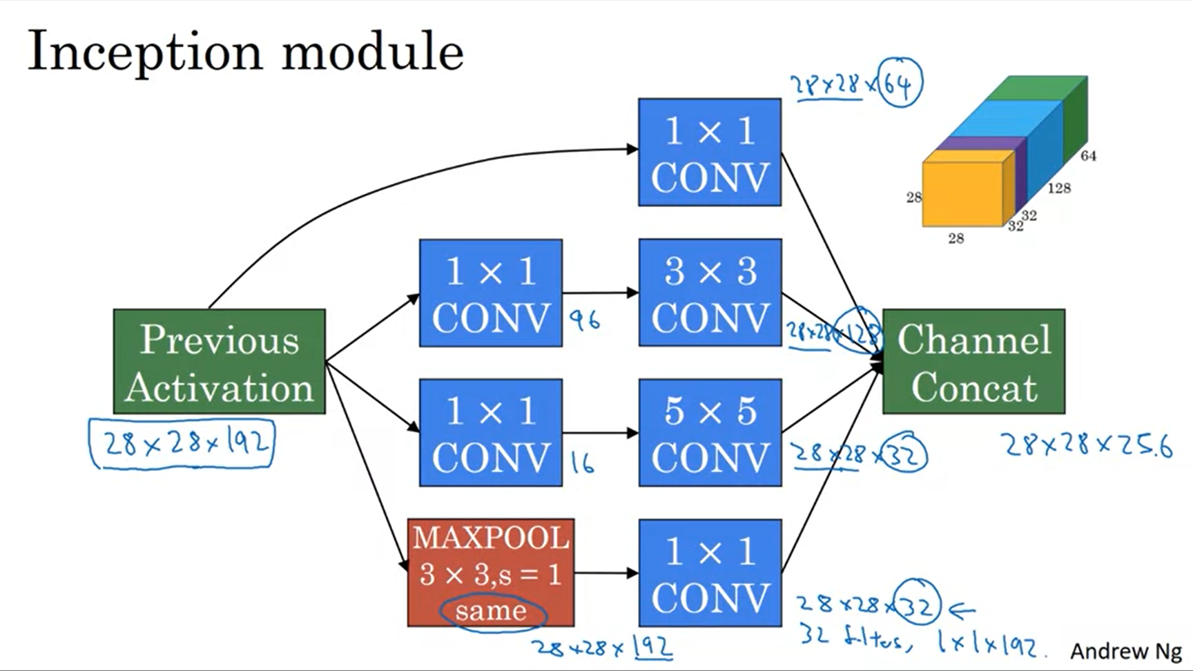

For the max pooling we add a 1x1 convolution afterwards to shrink the number of channels.

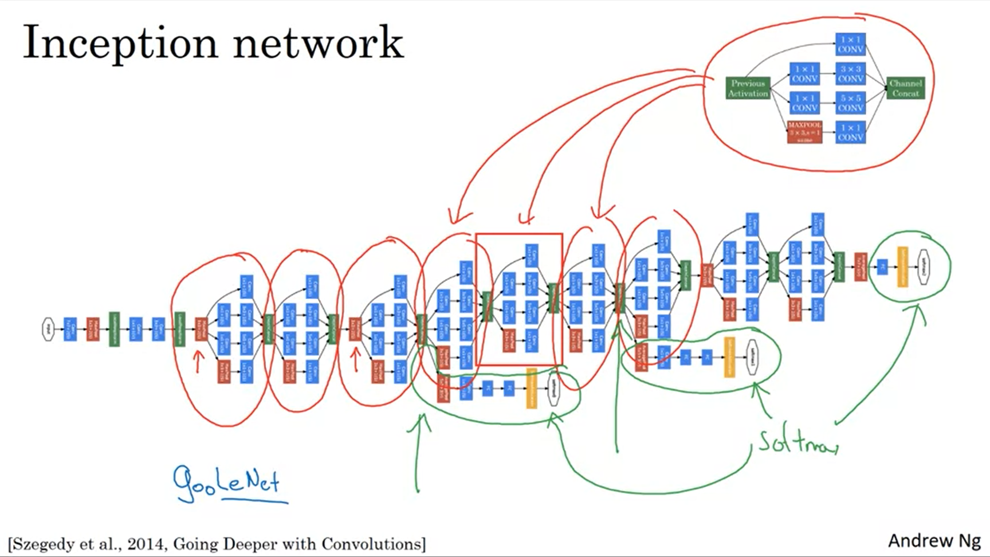

One of the blocks in this architecture is basically the inception module from the previous slide.

The red ones are inception blocks. There are also some max pooling layers in between.

There is one additional detail: side branches with softmaxes. They use the hidden layers to make a prediction already. This helps ensure that the computed features even in the hidden units are not too bad to detect the image. This has a regularization effect and prevents the network from overfitting.



The name comes from the movie. The authors actually cite this meme.

By now there are newer versions of the inception network (Inception V4). There is also an inception network that uses the resnet idea and works even better.